9/16/2018

Requirement Analysis document

ALIZA ANSARI, SAMAR HAIDER, ZAINAB AHMED, MUSFIRA ZAINAB, OSAMA ANSARI.

**INDEX**

1: INTRODUCTION:

* 1. Explanation of requirement documentation.
  2. Purpose of requirements.
  3. Scope of the system
  4. Success criteria of the system.

2: DISCRETE REQUIREMENTS:

2.1 [functional requirements](https://en.wikipedia.org/wiki/Functional_requirement) (e.g. what a product should do)

* + 1. Logging in
    2. Registration
    3. Receptionist access
    4. Manager access
    5. Meal selection
    6. Payment Management system
  1. Nonfunctional requirements (also known as "quality requirements")
     1. Usability
     2. Accuracy
     3. Security
     4. Reliability
     5. Flexibility
     6. Data Integrity
  2. External Interface Requirements
     1. User environment
     2. Software UI (DATABASE SERVER DEVELOPMENT END)
     3. Hardware Interface

**1- Introduction :**

* 1. What is a Requirements Document?

A requirements document explains why a product is needed, puts the product in context, and describes what the finished product will be like. A large part of the requirements document is the formal list of requirements.

* 1. Purpose of the system:

The sole purpose of creating a villa management system is to overcome the fallacies that arise in the manual registration system of a booking firm where human error may be a big cause of financial culpability, that might in longer terms adversely threat the overall business of the firm.

* 1. Scope of the system:

The VMS project is intended to for the reservations of rooms and the deliverance of timely meals for the stay-in guests. It will be able to operate the various aspects of operations that are conducted in a tourism based villa. The management system will consist of a database that will keep the bookings recorder. Customers will be able to check rooms’ availability select their desired types of rooms and then obviously pay for them through their desired means ( cash or card ).Manager will be able to update or modify the booking details & and will be able to update the room info such as cost and category. The automation will help eradicate the drawbacks that used to come handling the bulky huge files having large customer information. Security of data, quick reservations & swift retrieval of information will be the sheer advantages of our project.

* 1. Success criteria of the system:

***Real-time reporting and business intelligence***, ***quality system integrations,******data security,******ability to sell and market to guests efficiently,******pricing Intelligence;*** A leading hotel management system should provide a platform that will help you monitor your comp-set in real-time. This includes the ability to be notified of pricing increases or decreases.

2. DISCRETE REQUIREMENTS:

2.1 Functional Requirements:

2.1.1 Logging in:

The system should verify the admin and shall only allow the staff designated admin to get the access of the system.

2.1.2 Registration:

The customer shall be able to get registered into the system with their details by the admin.

Details should include;

1. Name
2. NIC no
3. Dob
4. Gender
5. Current Address
6. Number of people accompanied
7. Check in timings
8. Check out timings

2.1.3 Reservation:

1. The system should check for availability of rooms.
2. The system should display rates for all rooms types.
3. The system should allow the customer to confirm or cancel the booking on demand.
4. The system should record the booking details into the database.

2.1.4 Receptionist access:

The system should allow the receptionist to update, add or delete the booking information.

It will be the duty of the receptionist to make record of the payment given by the customer ( via cash or check )

2.1.5 Manager access:

The system should enable manager full modification access to customer bookings and room information.

2.1.6 Meal selection:

The System should incorporate details regarding the meals and drinks served in the villa and their costs accordingly.

The customer shall be able to make orders and for dine in.

2.1.7 Payment Management system:

The system shall record the payments made via cash or card, by the customers.

* 1. Nonfunctional requirements: (also known as "quality requirements")
     1. Usability:

The system should be usable by specified consumers to achieve quantified objectives with effectiveness, efficiency, and satisfaction in a quantified context of use.

* + 1. Accuracy:

The system shall be accurate in terms of calculations and timings recorded, for each and every customer.

* + 1. Security:

The system should be under surveillance of staff and no other member except of the designated ones shall be allowed to use the system under any means. The data of the customers shall be well-protected and should never leak out, keeping customer data integrity in the first place.

* + 1. Reliability:

The system shall be reliable to the customers, to gain their trust and acceptance.

* + 1. Flexibility:

The system shouldn’t be rigid to changes, it should always give space to sudden and unexpected modifications by user’s end or admin’s.

* 1. External Interface Requirements
     1. User environment:

The user shall be open to select the room number and the type of room they decide to stay in for as long as they reside in the villa, also they should be able to select and order for meals. Their environment shall be made as easy as possible for them to be easily be able to choose their items from them and it should contribute to making their stay convenient for them.

* + 1. Software UI (DATABASE SERVER DEVELOPMENT END):

Database Server:

MS Access.

DEVELOPMENT END:

C#, Visual Studios interface.

* + 1. Hardware Interface:

|  |  |  |  |
| --- | --- | --- | --- |
|  | SERVER SIDE |  | |
|  | Monitor Processor RAM | | Disk Space | |  |
|  | Resolution Intel core 4GB | | 1 TB | |  |
|  | 1024 x 768 | |  | |  |
|  |  | |  | |  |
|  |  | |  | |  |
|  |  | |  | |  |

|  |  |  |  |
| --- | --- | --- | --- |
|  | CLIENT SIDE |  | |
|  | Monitor Processor RAM | | Disk Space | |  |
|  | Resolution Intel core 4GB | | 10 GB | |  |
|  | 1024 x 768 | |  | |  |
|  |  | |  | |  |
|  |  | |  | |  |
|  |  | |  | |  |

THE END

DIAGRAMATIC REPRESENTATION TO VILLA MANAGEMENT SYSTEM.

**UML CLASS DIAGRAM:**

Manager

+Name: string

+Id: int

+PhoneNo: int

+Location: string

+Purchase Inventory()

+RecordComplaints()

+ManageStaff()

Receptionist

+Name: string

+Id: int

+phoneNo: int

+Location: string

+CheckRoomAvailability()

+BookRoom()

+GenerateBill()

+AcceptCustomerFeedback()

Inventory

+Type: string

+Status: string

Bill

+BillNO: int

+GuestName: string

Rooms

+RoomNo: int

+RoomType: string

+Location: string

Guest

+Name: string

+Id: int

+Gender: string

+PhoneNo: int

+Address: string

+RoomNo: int

+Check-In()

+Check-Out()

+PayBill()

+OrderFood()

Chef

+Name: string

+Id: int

+Location: string

+TakeOrders()

Housekeeping

+Name: string

+Id: int

+Location: string

+CleanRoom()

Food Items

+Id: int

+Name: string

**Sequence** **Diagram**

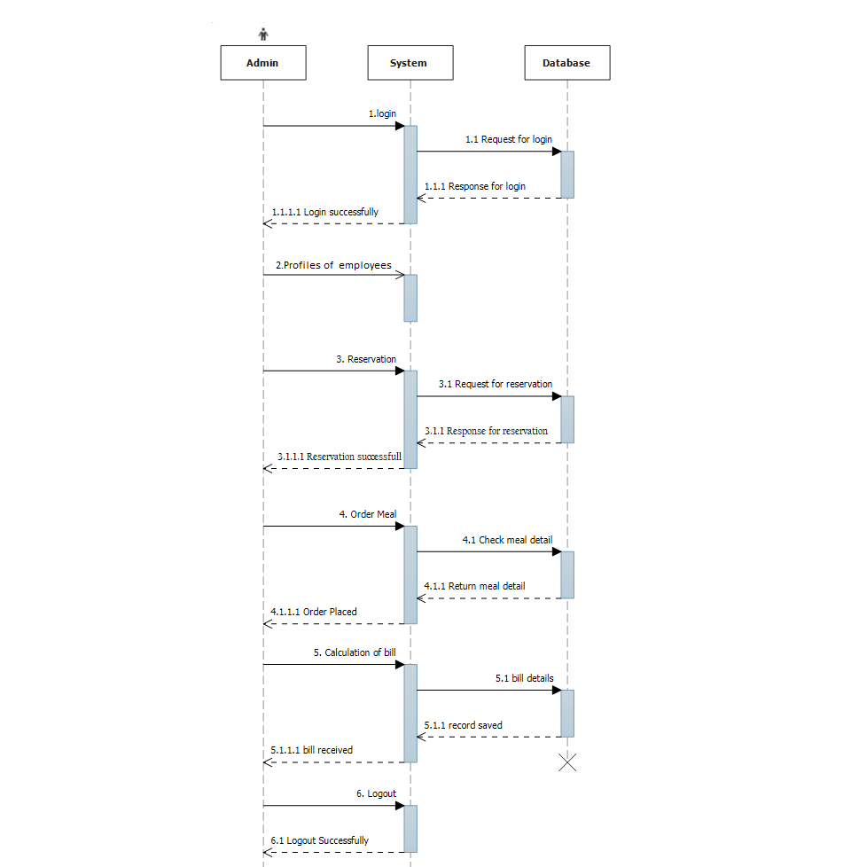

**Used Case Diagram:**

­­

ADMIN

USER/CUSTOMER



RECEPTIONIST